Heap DataStructure is used in HeapSort and Priority Queue

**How to sort the number using HeapSort?**A [***max heap***](http://algoviz.org/OpenDSA/Books/OpenDSA/html/Glossary.html#term-max-heap) has the property that every node stores a value that is *greater* than or equal to the value of either of its children. Because the root has a value greater than or equal to its children, which in turn have values greater than or equal to their children, the root stores the maximum of all values in the tree.

Note that there is no necessary relationship between the value of a node and that of its sibling in either the min heap or the max heap. For example, it is possible that the values for all nodes in the left subtree of the root are greater than the values for every node of the right subtree.

1. Build a max heap data structure. Also referred to as heapify (Shift Up).

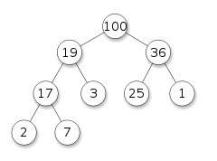

1. Sort it. (Swap)